Capstone-1 Project Proposal by Uma Gajendragadkar

Title of Project: Amazon Product Recommendation Engine

1) What is ​the problem you want to solve?

Whenever users visit online shopping sites like Amazon, Walmart, Ebay, flipkart etc. they search for various products to purchase. And many give reviews/ratings for a purchased product. We can make use of these reviews/ratings to recommend different products to current user.
Existing recommendation algorithms couldn't scale to Amazon's tens of millions of customers and products, so they decided to develop their own. Amazon currently uses item-to-item collaborative filtering, which scales to massive data sets and produces high-quality recommendations in real time.
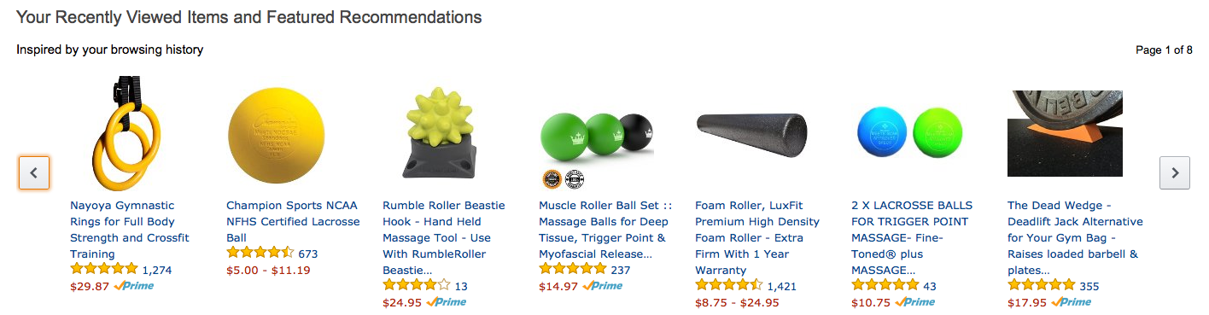
We can build a recommendation engine based on
a. Frequently Bought Together (Combo items)
b. Customers Who Bought This Item Also Bought
c. Related products ("users who purchased this also purchased")
d. Category wise best seller
e. Brand wise best seller
f. Similar Products

3) Who is your client and why do they care about this problem? In other words, what will your client do or decide based on your analysis that they wouldn’t have done otherwise?
Users visiting online shopping sites, e-commerce companies like Amazon, Walmart, Ebay, Flipkart etc.

4) What data are you using? How will you acquire the data?
Data from: UCSD http://jmcauley.ucsd.edu/data/amazon/
This dataset contains product reviews and metadata from Amazon, including 142.8 million reviews spanning May 1996 - July 2014. This dataset includes reviews (ratings, text, helpfulness votes), product metadata (descriptions, category information, price, brand, and image features), and links (also viewed/also bought graphs).

5) Briefly outline how you’ll solve this problem. Your approach may change later, but this is a good first step to get you thinking about a method and solution.
Approach : Collaborative filtering
Find similar items by using a similarity metric
For a user, recommend the items most similar to the items (s)he already likes to give you a high-level overview, this is done by making an item-item matrix in which we keep a record of the pair of items which were rated together. In this case, an item is a product.
There are 3 types of item similarity metrics.
a. Jaccard Similarity: Similarity is based on the number of users which have rated item A and B divided by the number of users who have rated either A or B. It is typically used where we don’t have a numeric rating but just a boolean value like a product being bought or an add being clicked
b. Cosine Similarity: Similarity is the cosine of the angle between the 2 vectors of the item vectors of A and B. Closer the vectors, smaller will be the angle and larger the cosine.
c. Pearson Similarity: Similarity is the pearson coefficient between the two vectors.

6) Is this a supervised or unsupervised problem?
It is a Supervised problem
7) If supervised is it a classification or regression problem?
It is more of a regression problem in this case as I am trying to predict the rating of a product to be recommended
8) What variable is it you are trying to predict?
Rating of the product/item
9) What variables will you use as predictors?
Similarity score between items/products
10) What will be your training data?
Available data will be divided as training and testing dataset
11) What are your deliverables?
Algorithm for product recommendation (Code in Python), Charts, Presentation, Report, a blogpost

